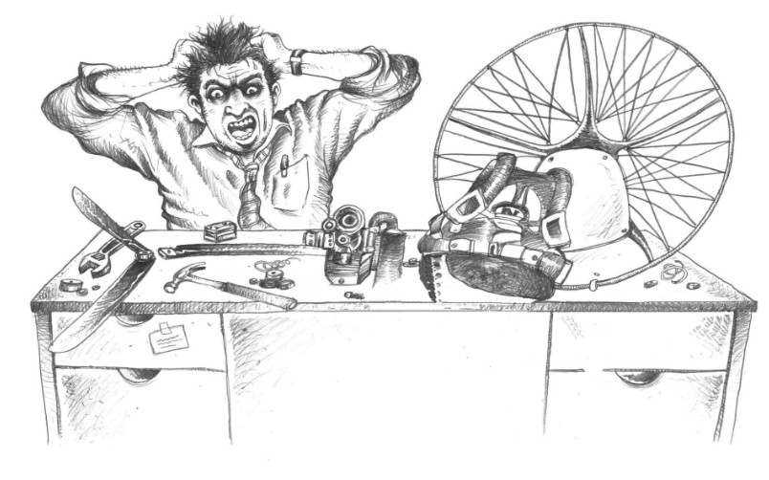

Density altitude for paragliders and paramotor pilots
Technical note for instructors and pilots · Version 1.0 · 30 October 2026
Paramotor SA (Pty) Ltd t/a Apex Adventures · SACAA DTO 0012

Technical notes · General

Scope. What density altitude is, how to work it out, and what it does to take-off run, lift, sink rate, engine power and carburettor setting on a paramotor (PPG) and on a free-flight wing. It builds on the Apex "Density Altitude" Tech Dummy note. The physics and the engine figures are published. The take-off run figures for paramotors are our own model estimates, because no PPG-specific tables exist. Aeroplane rules of thumb are shown beside them for comparison. Where a wing or engine manufacturer publishes a figure, the manufacturer's figure wins.

1. What density altitude is
Density altitude (DA) is the altitude in the standard atmosphere at which the air has the same density as the air you are standing in. A hot, low-pressure day at a 4,600 ft field can "feel" like 7,500 ft or more. Your wing, prop and engine do not care what the altimeter says. They only respond to how many air molecules there are.
Three things make the air thin:
- Height. Pressure falls about 1 hPa for every 30 ft you climb.
- Heat. Warm air expands, so each cubic metre holds less air. This is the biggest day-to-day swing.
- Low pressure and humidity. A low QNH raises pressure altitude. Humid air is slightly lighter than dry air. It matters less than heat, but on a hot humid day it can add 1,000 ft or more.
The effect for us: the wing flies at the same indicated airspeed and the same stall speed, but its true speed over the ground is higher. Everything takes longer, needs more speed, and the engine makes less thrust to do it.

2. How to calculate it
You need the field elevation, the QNH (or the pressure altitude) and the outside air temperature (OAT).
- Pressure altitude (PA) = field elevation + (1013 − QNH) × 30 ft. At QNH 1013, PA = elevation.
- ISA temperature at that height = 15 °C − (2 °C × PA in thousands of feet).
- Temperature difference = OAT − ISA temperature.
- DA = PA + (120 ft × temperature difference).
Worked example (Grasslands, 4,600 ft, QNH 1013, OAT 32 °C). PA = 4,600 ft. ISA at 4,600 ft = 15 − 9.2 = about 6 °C. Difference = 32 − 6 = 26 °C. DA = 4,600 + (120 × 26) = about 7,700 ft.
Quick rule of thumb (in your head, at the field). Start at the field elevation (QNH about 1013). Add 120 ft for every °C above 15 °C (subtract if colder). Then add a quarter of the field elevation (this is the ISA correction, 250 ft per 1,000 ft). If the QNH is low, add 30 ft per hPa below 1013.
Grasslands, 4,600 ft, 32 °C: 4,600 + (17 × 120 = 2,040) + (¼ × 4,600 = 1,150) = about 7,800 ft (exact method: 7,700 ft). Within about 100 ft is good enough for planning. Use the full method when the margin is tight.
Common mistake. Do not compare the OAT with the sea-level 15 °C. On the same Grasslands day that gives 4,600 + 120 × (32 − 15) = about 6,600 ft, which is roughly 1,100 ft too low. ISA is already colder at 4,600 ft (6 °C), so always use ISA at your own pressure altitude.

Quick table: density altitude for common days
Field elevation | OAT | QNH | Density altitude
Sea level | 15 °C | 1013 | about 0 ft
Sea level | 35 °C | 1013 | about 2,400 ft
1,700 ft | 30 °C | 1013 | about 3,900 ft
4,600 ft (Grasslands) | 5 °C | 1013 | about 4,500 ft
4,600 ft (Grasslands) | 15 °C | 1013 | about 5,700 ft
4,600 ft (Grasslands) | 32 °C | 1013 | about 7,700 ft
6,000 ft | 30 °C | 1013 | about 9,200 ft

Rule of thumb: every 1 °C above standard adds about 120 ft; every 1 hPa below 1013 adds about 30 ft. Many phone weather apps and flight computers show DA directly. Use them, but know how to check the number.

3. What it does to the air and the wing
The table gives the air density and the engine power against density altitude. Air density falls about 3% per 1,000 ft at low level.
Density altitude | Air density (sea level = 100%) | True speed for same indicated speed | Engine power (estimate)
0 ft | 100% | +0% | 100%
2,000 ft | 94% | +3% | 94%
4,000 ft | 89% | +6% | 88%
6,000 ft | 84% | +9% | 82%
8,000 ft | 79% | +13% | 76%
10,000 ft | 74% | +16% | 70%

Effects on the wing:
- Same lift, more speed. Lift needs a certain dynamic pressure. In thin air the wing reaches that at the same indicated speed but a higher true speed.
- Faster inflation and launch run. You must run faster over the ground to reach flying speed. The ground speed at lift-off is higher by the true-speed increase above.
- Higher sink rate. Sink in metres per second goes up with true speed. The glide ratio stays about the same, but you land harder and flare later.
- Weaker thermals and mushy handling. Control response and flare effect are reduced, and in hot conditions thermals are strong and turbulent. A heavy-loaded or small wing suffers most.
- Lower service ceiling. Climb rate falls steadily with DA.

4. What it does to the paramotor
Engine power falls with density altitude. A normally aspirated two-stroke loses about 3% power per 1,000 ft (US FAA Pilot's Handbook of Aeronautical Knowledge) to 3.5% per 1,000 ft (Walbro service manual). There is no turbo or supercharger on our engines to recover it.
Propeller thrust falls with it. The prop bites less air, and static thrust drops by at least as much as engine power. A fixed-pitch prop that suits sea level becomes over-pitched for the thin air and cannot pull full rpm in the same way. Check static rpm on the day and compare it with the engine's known figure.
Carburettor mixture changes. A fixed-jet carburettor meters fuel by volume, not by weight of air:
- Flying at a higher density altitude than the jets were set for gives a rich mixture. It runs rough, smokes and loses power.
- Flying in denser air than it was set for (cold morning, or moving down to a lower field) gives a lean mixture. That is the dangerous one: engine heat rises and it can seize.
- A density change of about 5% (roughly 1,700 ft DA) is enough to need an adjustment or a jet change on a fixed-jet carburettor.
- On a Walbro WB37C the HI and LO needles give some range. See the Walbro WB37C Technical Note for the settings and the pop-off check.
Source conflict on mixture. Some books say engines "run rich at altitude" and others warn of leaning on cold days. Both are true. The mixture is correct only for the density it was set at. Always check the plug colour, the rpm and the exhaust gas or cylinder head temperature (EGT or CHT) after any change in field, season or temperature. Do not lean an engine to chase rpm without the CFI's approval.
Cooling. Thin air carries less heat away. Hot days at altitude push CHT and EGT up at the same time as the engine is working hardest on take-off. Watch the temperature gauges and do not hold full power on the ground longer than needed.
Engine size. To keep the same thrust at a higher DA you need more power from the engine, a bigger engine, or a bigger and slower-turning prop. A 100% sea-level engine only gives about 80% at 7,000 ft. Heavy pilots and hot, high fields call for the larger engine rather than a smaller one working at its limit. A higher-altitude site may also warrant a different prop, or a reduction-ratio change, as the engine and prop maker allow.

5. What it does to take-off run
The wing needs a certain indicated airspeed to fly. The run to reach it depends on two things that both get worse at high DA: the true ground speed needed goes up, and the thrust you have to accelerate goes down. Run length is roughly proportional to the ground speed squared divided by the acceleration.
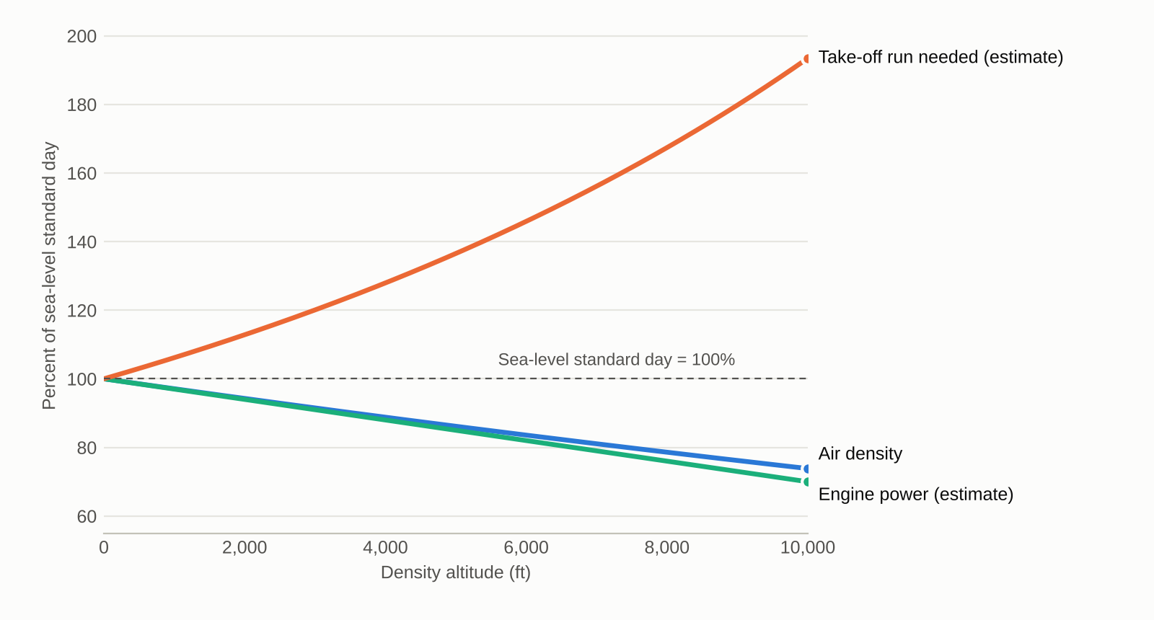
Air density, engine power and take-off run against density altitude, as a percentage of a sea-level standard day. Model estimate: density from the standard atmosphere, power at 3% per 1,000 ft, run = 1 ÷ (density × power). Apex calculation.
Density altitude | Run, our PPG model | Run, aeroplane rule (+12% per 1,000 ft)
0 ft | 100% | 100%
2,000 ft | about 113% | 124%
4,000 ft | about 128% | 148%
6,000 ft | about 146% | 172%
8,000 ft | about 167% | 196%

Our model gives roughly +6% run per 1,000 ft. The aeroplane rule gives +12% per 1,000 ft. A paramotor pilot is not an aeroplane: the wing inflates and the run is partly your own legs. Plan on something between the two, and treat the larger number as the safe one until we have our own field data. These are estimates and not published PPG figures.
Other things that change the run (aeroplane rules of thumb, used as a guide):
- Weight. +10% weight gives about +20% run. Fuel, a heavy pilot and a passenger all count.
- Wind. Headwind shortens the run by about 1.5% per knot. A tailwind of 5 kt can lengthen it by about 25%. Never launch downwind.
- Surface. Long grass or soft sand adds about 14% or more.
- Slope. An uphill take-off of 2% adds about 15%. Launching downhill into a headwind is the best case.
- Temperature through the day. DA is lowest early in the morning. Fly early.

6. The dangers
- Running out of field. The run is longer than you are used to, you commit, the engine is not pulling and you are still on the ground at the fence.
- Low climb-out and no energy. The climb rate (about 7% less per 1,000 ft in aeroplane figures) is poor, and you do not clear trees, power lines or the rotor behind them.
- Overheated or seized engine. Heat, a lean mixture and a long full-power run together.
- Hard landings. Higher true speed and sink rate, with a less effective flare, especially after a long hot flight.
- Turbulence. Hot days at altitude mean strong thermals, rotor and dust devils at launch and landing.
- False confidence. Last season's take-off at the same field, in winter, tells you nothing about a hot afternoon in summer.

7. How to solve it

Before the flight
- Work out the DA for the field, using the method in section 2. Do it again if the day heats up.
- Fly early or late. Take off in the cool hours when the air is densest and the wind is light and steady.
- Plan a longer run. Pace out the field. Add margin: at least +25% at a DA of 4,000 ft and +50% or more at 6,000 ft and above, until the CFI has set our own limits.
- Reduce weight. Fly with the fuel you need, not a full tank. Leave out heavy extras.
- Choose the wing and engine to match. A larger wing or a lower wing loading and a bigger engine for hot high sites.
- Check the engine and carburettor against the day. Set the mixture for the conditions as the manual allows. Check plug colour, static rpm and temperatures.

On the day
- Take off into the wind, up the slope if you can, from the best surface (short, firm grass).
- Do a full-power static check at the start and compare rpm with your usual figure. Low rpm means thin air or a wrong setting. Do not launch on an engine that is not pulling.
- Set a go/no-go point. Pick a mark on the field. If you are not flying by then, abort the run, close the throttle and brake the wing. Do not run past it.
- Keep the wing inflated and in control and fly off at the speed the wing needs. Do not drag it off with the nose low and a poor climb.
- Keep the first climb straight and shallow until you have a safe height and speed. Watch the temperature gauges.
- Land earlier and flatter and plan for a faster approach and a longer flare.
Limits need CFI approval. The percentages and margins in this note are guides. Apex limits (for example a maximum DA for training, student and tandem or two-up flights) are to be set by the CFI and recorded in the operations manual. Until then, no student take-off at a DA above the figure the CFI sets, and no take-off without a go/no-go point.

8. Density altitude record
Copy one line per flight day. Record before the first take-off and again if the temperature rises by more than 5 °C.
Date | Field and elevation | OAT, QNH | DA (ft) | Run, rpm, notes | Done by | CFI check

9. Sources and cautions
- Density Altitude (Apex Adventures Tech Dummy note, 2 pages). The starting point for this note.
- Pilot's Handbook of Aeronautical Knowledge (US Federal Aviation Administration). Definition of density altitude, effects on performance, and about 3% engine power loss per 1,000 ft.
- Mountain flying: take-off and climb rules of thumb (mountainflying.com, and New Zealand Civil Aviation Authority guidance). Run and climb percentages for aeroplanes, used for comparison only.
- Walbro WB service manual. Engine power loss of about 3.5% per 1,000 ft and the effect on fixed-jet carburettor mixture.
- Vittorazi Moster 185 Plus maintenance manual (MY25). Carburettor settings, used with the Walbro note.
- International Standard Atmosphere. Air density against height, used for the table and chart.
Cautions.
- The take-off run figures for paramotors are model estimates and not measured data.
- Figures assume dry air. Humidity adds more, so treat hot humid days with extra care.
- Engine power loss varies with the engine and prop. Measure your own static rpm.
- This note is a technical aid. It does not replace the manufacturers' manuals or the DTO's procedures.
Reviewed and approved by CFI: ___________________________ Date: _____________

